**Day-01**

**04-02-2025**

**============**

**Introduction**

**=========**

**What is Data?**

**==========**

-> An information about any physical entity is called as "Data".

Ex: Employee

name:

Organization:

Salary:

Position:

Location:

Manager:

**What is Database?**

**=============**

-> The database is a software

which can use to store the data/information of more than one physical entity.

Ex:

====

Employee1 Employee2

========= =========

Ravi Karthik

Software Developer Software Tester

75000 670000

Hyderabad Hyderabad

Ashok Ashok

**DBMS**

**=====**

-> Database Management System

-> It is an interface between Application and Database.

**How DBMS can work?**

**==============**

1) End-user Request:

====================

-> this can use to prepare the request for making any operations on the database.

-> SQL can use to prepare the user request.

2) Query Processor:

=============

-> Query ==> User request (Statement)

-> Query Processor can check the Query whether it is correctly written or not.

-> If it is not, then that query can stop to process.

-> If it is correctly written, that request can optimize to make it execute faster.

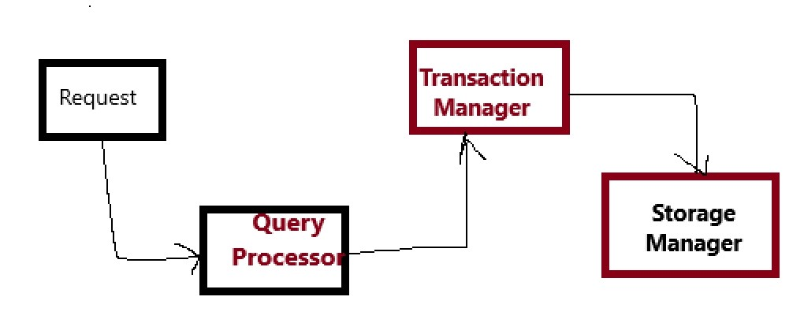

3) Transaction Manager:

================

DBMS responsible for ACID principles:

A ==> Atomicity ==> The request is to entire system or not

C ==> Consistency ==> Database consistently maintain data before the request and after the request also

I ==> Isolation ==> Avoiding the interference among multiple request

D ==> Durability ==> Maintain the data because of success or failure of the system.

4) Storage Manager

==============

-> can use to interact with database to store the data according the processing of request.

-> after that, the storage manager can respond back to the end-user about that request.

**Various Techniques to manage data**

**========================**

**1) Traditional Approach:**

**================**

-> managing the data in books/ledgers is called as "Traditional approach".

-> With this approach we have some drawbacks:

1) Time consuming

2) Costlier

3) No security

4) No backup

**2) File Manager:**

**============**

-> Any data can maintain in computers in the form of files.

-> Drawbacks:

1) Time consuming

2) No safety

3) Limited data can be handled.

**3) Database:**

**===========**

-> maintain very huge amount of data

-> more secure

**Day-02**

**05-02-2025**

**============**

**RDBMS**

**=====**

-> Relational Database Management System

-> RDBMS is a process of storing the data in the database.

-> In generally, the data can be organized in structured format by the DBMS.

-> Structure ==> Tabular format

-> Table is the combination of rows and columns.

Ex: Employee Table

Id Name Designation Department salary

========================================

101 Manoj Software Associate X 40000

102 Mahesh Software Engineer X 50000

Department Table

Code Department name

==================

x Development

y Testing

Z Accounting

**Terminologies:**

**==========**

1) Table ==> Representing a relation

2) Column ==> the data which is representing in column is called as "field"

3) Row ==> The data which is representing in row is called "value" or "Tuple".

**RDBMS Architecture:**

**==============**

UI =======> Query Processor ==========> Transaction Manager =======> Storage Manager

(End user

request)

**How RDBMS different than DBMS:**

**=======================**

1) Data Storage Mode:

===============

DBMS: can store the data in file format (Hierarchical)

RDBMS: can store the data in the table format.

2) Relation between the data:

===================

DBMS: not ensure any relation between the data

RDBMS: can ensure the relation between the tables.

3) Data Integrity & consistency:

====================

DBMS: not give any assurance for the data integrity and consistency because it cannot apply ACID properties strictly.

RDBMS: give any assurance for the data integrity and consistency because it can apply ACID properties strictly.

4) Normalization:

===========

DBMS: does not support normalization, so we can create the file with same name again and again (duplication)

RDBMS: can support the normalization, so we cannot do duplication for the data.

5) Query Language:

=============

DBMS: may or may not need the Query language

RDBMS: need either SWL or Pl-SQL

6) Scalability & Performance:

===================

DBMS: can use small-scale applications

RDBMS: can use for large-scale applications with more complex functionalities.

7) Examples:

=========

DBMS: Mongo DB

RDBMS: Oracle, MySQL, SQL Server, Postgre SQL etc.

**Types of Database Software:**

**===================**

1) RDBMS Database Software

====================

->also called as "SQL (sequel) based database software’s

-> The RDBMS software’s are:

Oracle Database Software ==> Oracle corporation

MySQL Database Software ==> Oracle corporation

DB2 database Software ==> IBM

SQL Server ==> Microsoft

Postgre SQL etc.

2) NRDBMS Database Software

====================

-> No SQL based database software’s

-> classified into different types:

1) File based Database software’s ==> MongoDB

2) Key-value pair based ==> Cassandra

3) Graph based ==> Neo4j

4) Column based ==> HBase

**Day-04**

**06-02-2025**

**===============**

**Oracle Database Software:**

**==================**

Oracle is one of the SQL based Database software.

Oracle has two parts:

1) SQL ==> Structured Query Language

2) Pl/SQL ==> Procedural Language with SQL

-> Using SQL, we can send only one Query at a time to the Oracle database.

-> When we want to perform block of actions on the Oracle software, then we can use "Pl/SQL".

**Oracle Software Setup:**

**===============**

1) We have multiple versions for Oracle database software, among those express editions are open source and free to all.

2) For our computer, light weighted software which 11g expression edition is enough to do any practice.

3) To download Oracle 11g Express edition

i) use this link:

https://www.oracle.com/database/technologies/xe-prior-release-downloads.html

ii) Based on your system configuration, click on the download link.

iii) For downloading, we should create an account with Oracle corporation.

iv) After the completion of Registration or account create, do the login into Oracle website.

v) Then automatically file can get start download.

4) After the downloading:

we should extract the zip folder into normal folder.

right click on the zip folder ===> extract all

5) After the extraction, we should install that software:

i) Open Oracle 11g Folder

ii) Open Disk1 folder

iii) Double click on "setup.exe" file to installation

iv) After the preparing for installation, we can get new window:

click on next

accept the agreement

click on next

click browse option to select the drive into which we want to install.

click on next

we required set password:

password: system

confirm password : system

then click on next

click on install.

==> after the installation, click on "finish".

**How to interact with Oracle Database software:**

**===============================**

-> three ways:

1) Using CLI (Command Line Interface)

2) Using Oracle web application

3) Using GUI (Graphical User Interface)

1) Using CLI (Command Line Interface)

=========================

SQL CLI is also named as "SQL * Plus".

-> To open this:

Go to start menu

search about SQL

Open Run SQL command line

-> After the starting of CLI of SQL:

enter a command "connect"

hit enter

enter user name as "system"

enter the password (which was used at the time of installation)

hit enter button

-> Try these commands:

show user;

select * from all_users;

exit

**Syllabus of SQL**

**===========**

Module-1: SQL Basics

Syntax

Datatypes

Operators

Module-2: Data Manipulations

CRUD operations

Batch Operations

Constraints

Triggers

Commands:

DDL, DML, TCL, DQL/DRL

Module-3: Advanced SQL

Joins,

Clauses

Subqueries

Set Operations

CTEs (Common Table Expressions)

Module-4:

Window Functions

Module-5: Functions & procedures

Module-6: Transactions & concurrency

Module-7: Error Handling

Module-8: Indexing

Module-9: Performance & optimization

**Day-05**

**07-02-2025**

**===============**

**Interaction with Oracle using Web application:**

**===============================**

Click on Desktop Icon

Application Express

To create new user:

provide the details like:

user name

application user name

password

re-enter password

create workspace

click on SQL Workspace

Click on SQL Commands

type a command:

select * from all_users

**Interaction with Oracle using GUI (Graphical User Interface)**

**======================================**

There are two GUI options:

1) SQL developer

https://www.oracle.com/in/database/sqldeveloper/technologies/download/

-> After the downloading,

convert the zip folder into normal folder

-> open the normal folder:

run the file "sqlDeveoper.exe"

creation of new user:

==============

click on '+'

Enter user name as "DBA_Connection/Ravi/Ganesh" etc

Select the color

Enter user name : system

Enter password: system

click on "Test"

after the displayed with "success"

click on "connect".

then start to write queries.

2) Toad

**Day-06**

**18-02-2025**

**===============**

Oracle Software installation, we have created an Database account with credentials

username : system

password : system

-> these are called as "System credentials" or "DBA (Database Admin) Account Credentials".

**Q: DO WE ABLE TO CREATE NEW DATABASE USER USING CLI?**

**======================================**

ANS: yes

How:

====

1) start the SQL* plus

(Start menu --> search for SQL --> click on "SQL Run command line" )

2) To create the new Database user account, first we should do the login with system credentials (DBA Credentials)

enter a command: connect + enter

enter user name: system

enter password: system

click on enter

3) We need to confirm that whether we have logged in with DBA Account or not.

By using the below command:

$ show user

4) After the confirmation, we can create the new Database user account by the following the below command:

$ create user username identified by password;

Ex: connect user rajesh identified by rajesh;

5) After the creation of new Database user account, to use or work with database objects, that user account must required with required permissions.

-> To provide the permissions, we need to follow this command:

$ grant resource, connect to username;

Ex: grant resource, connect to rajesh;

6) After the granting of the permissions, we can use this command:

$ show user

to check whether we have connected with new database user account.

At this time, we were not connected.

7) To make connection with new database user account:

connect

enter user name: rajesh

enter password: rajesh

click on enter

**How to delete the Database user account?**

**===========================**

$ drop user username;

Ex: drop user rajesh;

**Intro to SQL:**

**=========**

-> SQL is the programming language which can be used to interact with the database software by an end user. SQL also called as "Database Query language" or "Database programming language".

-> SQL is abbreviated as "Structured Query Language".

-> SQL is case insensitive programming language.

Ex: $ create user rajesh identified by rajesh;

$ CREATE USER RAJESH IDENTIFIED BY RAJESH;

-> According to the business requirements, when we want to execute block of SQL queries, SQL is not suggested. We can use "PL-SQL (Procedural Language with SQL)"