**Day-08**

**19-02-2025**

**==================**

**SQL Commands:**

**===========**

-> SQL commands are used to create the SQL statements.

-> SQL commands can understand in any case format.

-> There are 5-types of SQL commands:

1) DDL (Data Definition Language) commands

=============================

-> DDL commands can work on the structure of Database object.

-> These commands can be required for the creation of object, altering of the object, deleting of the object etc.,

-> The DDL commands:

1) create

2) alter

3) drop etc.,

2) DML (Data Manipulation Language) Commands

================================

-> DML commands can always implement on existing data

Ex: Insertion of new entry

modification , deleting of the entry.

-> DML commands are:

1) insert

2) update

3) delete etc.,

3) DCL (Data Control Language) Commands

=============================

-> DCL commands can be responsible for controlling of the object like:

grant the permissions, releasing of the permissions etc.

-> DCL Commands are:

1) grant

2) revoke

4) DRL (Data Retrieval Language) Commands

=============================

1) select

2) show

3) description

5) TCL (Transaction Control Language) Commands

=================================

rollback

commit etc.

Ex: IRCTC

1) login

2) filling data

3) select train

4) select seats

5) proceed payment

**Day-09**

**20-02-2025**

**===============**

**SQL Syntax:**

**========**

-> Syntax: group/collection of rules

when we want prepare the queries/statements for the interactions with database software, we need the syntax.

Syntax:

=====

for the creation of the table object

create table Table-name(

<column-name datatype>,

<column-name datatype>,

<column-name datatype>,

...........,

<column-name datatype>

);

**SQL Keywords:**

**==========**

-> Keywords are also called as "pre-defined words" or "Reserved words".

-> total 40 keywords

-> Each keyword has the definite meaning can be used to perform definite action.

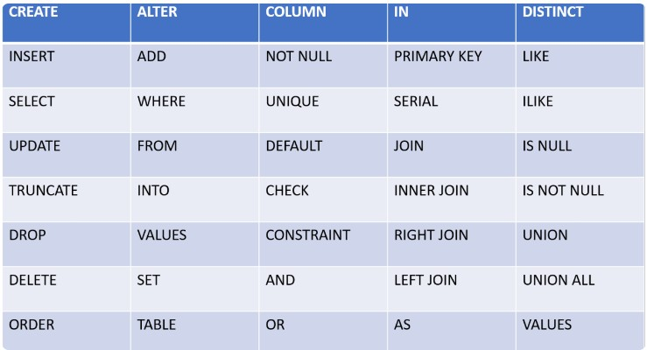

**Identifiers:**

**========**

-> Identifier is a name

can be used to name any entity within the query.

-> In SQL, we can define identifiers in two ways:

1) General Identifiers/Normal Identifiers

=========================

-> any identifier without quotes ("") or square bracket ([]) called as "General identifiers".

Ex: empid

2) Delimiter identifier

==============

-> Any identifier with quotes or [] called as "delimiter identifier.

Ex: [emp id]

Note:

=====

SQL identifiers are always case insensitive for Oracle database software.

whereas, for postgre SQL or SQL Server etc. SQL identifiers are case sensitive.

**Identifier Rules/Naming Conventions:**

**========================**

1) Identifiers can allowed to define with characters like:

Alphabets (Upper case/lower case)

Digits (0 to 9)

Underscore sign (_)

Note:

====

1) No other special characters (space,.?...) not allowed

2) For delimiter identifiers, we can allowed to use space in between name.

2) The SQL identifier can start with either alphabet or underscore but not with the digit.

Ex: empName, empName2, emp_name, _emp etc., ==> valid identifiers

9emp_name, emp#name ==> Invalid (error)

3) No keyword can be used as an identifier

4) Identifiers are case insensitive for few RDBMS database softwares (Oracle, MySQL ...)

Whereas for few RDBMS database softwares, identifiers are case sensitive (Postgre SQL, SQL Server etc..)

**Day-10**

**21-02-2025**

**===============**

**Declarative Language:**

**===============**

-> Like other high level languages (Java,c++) the SQL does not support the control flow of execution using conditional statements, loop statements etc. These kind of languages are called as "Declarative languages".

Ex: SQL

**Q: Is SQL compiler dependent or interpreter dependent?**

**=====================================**

SQL is interpreter based language because the SQL while the interaction with database it possess or send only one statement at a time.

**Q: How SQL statement can execute?**

**========================**

In database server, there is a query processor can process your query through four functional blocks:

1) Query Parser

2) Query Optimizer

3) Interpreter

4) Execution block

1) Query Parser

==========

-> can receive the query/statement/command of SQL from query processor.

-> checks the syntax of query whether it is correct or incorrect.

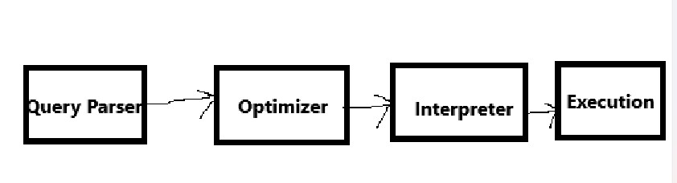

2) Optimizer:

=========

-> Can check the query

-> possess the plan for the execution.

3) Interpreter:

==========

SQL query can be translated into object code (1's and 0's).

4) Execution:

=========

-> the object code can run on the database software and give the result.

**Datatypes:**

**=======**

-> The type of the data in which format we need to store the data into database.

-> Available datatypes are:

1) Number type

2) Character & String Type

3) Boolean Type

4) Date

5) Binary type etc.