**Introduction**

**10-03-2025**

**=================**

JAVA OR PYTHON

FOR DEVELOPMENT OF APPLICATIONS

-> Application is the collection of programs to perform one or more than one functionality.

-> The application can always run on the platform (OS)

Ex: Instagram ==> mobile based application

we need mobile based platform (OS)

Android or IoS etc.

-> Different types of applications are:

1) Standard Applications

2) Web applications

3) Distributed applications

-> Every application need the storage

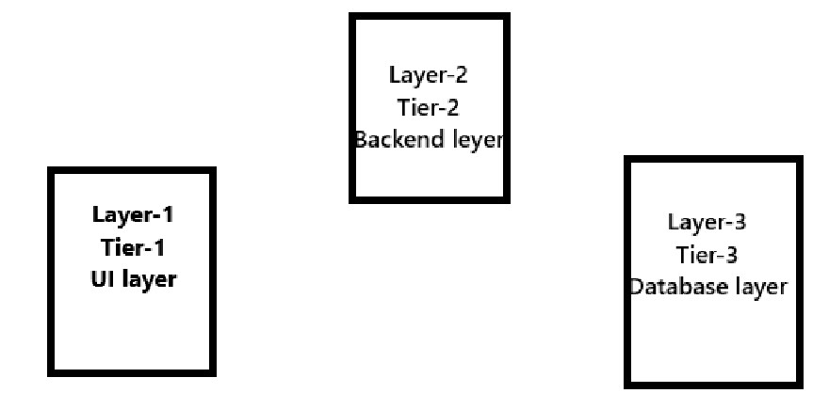

Ex: IRCTC is the web application need the storage called as "Database".

-> Any web application can define with three layer architecture.

The three layers are:

1) Layer-1/Tier-1 --> UI (User Interface) layer

when an end-user want to interact with an application, layer-1 can be used.

2) Layer-2/Tier-2/Application Logic Layer/Application Processing layer

it consists of all the logics related to the application

3) Layer-3/Tier-3/Database layer

where we can store the data related to application

-> Database can perform four important operations, those are called as "CRUD Operations"

Here:

C ==> Create

R ==> Read

U ==> Update

D ==> Delete

-> To interact with database, we have two types of programming languages:

SQL ==> Structured Query Language

Pl-SQL ==> Procedural Language with SQL

-> Different types of Databases are:

Oracle, SQL Server, Postgre SQL, MySQL, Mongo DB etc.

-> While interaction with Database software, if we can use only one statement at a time we can use "SQL"

-> When we can send more than one statement to the Database software, we can use "pl-SQL".