**DBMS (Database Management System):**

**==========================**

What is DBMS?

-----------------

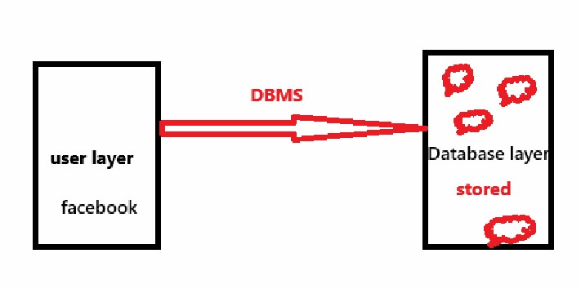

-> DBMS is abbreviated as "Database Management System".

-> DBMS is a software or process or technique can provide an interface to the user layer and database layer for performing:

1) create storage

2) access storage

3) update storage

4) delete storage etc.

Features of DBMS:

----------------------

1) DBMS can be for storage and for access control

2) Accuracy

3) redundant

4) Secure access

How DBMS can work?

==============

DBMS has different functional blocks:

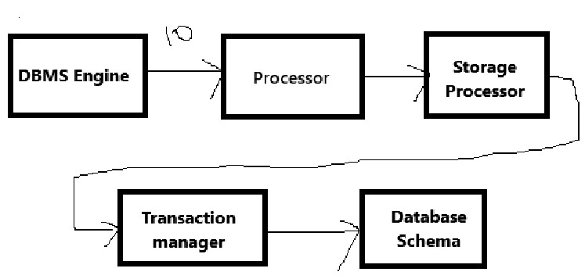

1) DBMS Engine:

-------------------

-> can check and read the query/statement is in the correct format or not for the execution.

2) Processor:

---------------

-> can provide the priority for each query before the execution.

3) Storage processor:

-------------------------

-> can maintain the next query which want to execute.

4) Transaction Processor:

-----------------------------

-> can apply the ACID (Atomicity, Consistency, Isolation and Durability) before the execution.

5) Database Schema:

------------------------

There are four types of DBMS:

1) Hierarchical DBMS

-------------------------

-> This can maintain the data in tree format

Ex: File Management System

2) Network DBMS

--------------------

-> can maintain the data in the format of links.

Ex: routers etc.

3) Relational DBMS

----------------------

-> The data can be maintained in the format of some relations like tables.

-> table consists of rows and columns to manage the data.

Ex: Oracle, MySQL, Sql Server, DB2 etc.

4) Object DBMS

------------------

-> The data can store and manage in the object format.

Ex: Neo4j

-> according to the type of DBMS, the database schema can decide the format or structure of data to store.

ACID Properties:

--------------------

->There are four ACID properties:

1) Atomicity

-------------

-> Ensures that a transaction is either fully completed or not executed at all.

Ex: user1 -------------> sending money ----------------> user2

10000

user1 ==> sufficient funds

10000 can be deducted from user1

add to user2

transaction successful/Failure

2) Consistency

---------------

-> Ensures that a transaction is either fully completed or not executed at all.

user1 ====> 10000 ===> user2

user1 have 5000 only

3) Isolation

-------------

-> Ensures that concurrent transactions do not interfere with each other.

Ex: IRCTC

user1 & user2 ==> logged in

vizag ==> 11pm ==> 1 ticket

4) Durability

-------------

-> Ensures that once a transaction is committed, it remains permanent, even if there is a system failure.

-> Bank application

history can be maintained after the restart the system also.