**Day-07**

**18-03-2025**

**====================**

-> During the installation of Oracle database software, we have created a DBA (Database Administration) Account with the following credentials:

user name: system

password: system

**Q: How we can create a user for the Oracle database software using CLI?**

1) start the "SQL * plus"

i) go to start/search in the windows

ii) search about: "SQL"

iii) Click on "Run SQL Command Line".

2) Then give a command to connect with the database software by DBA account:

$ connect

then enter these details:

user name: system

password: system

and hit enter

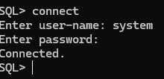

3) To check the users under the DBA by using the below command:

$ select * from all_users;

4) When we want to create the user under DBA, we can follow the below procedure:

i) use the below command

$ create user <user-name> identified by <password>;

Ex: create user ravi identified by ravi;

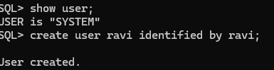

ii) After the creation of the account, we should provide the grant for that user by using the below command:

$ grant resource, connect to <user-name>;

Ex: grant resource, connect to ravi;

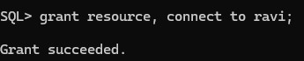

5) After that, we can follow the below command to connect with database software:

$ connect

enter below details:

user name: ravi

password: ravi

hit enter

**Q-2: How to delete the user from the database software using CLI?**

1) If we want to delete any user, that is possible with DBA account only.

So, we need to do the login with DBA account.

2) Delete the user from the database software using the below command:

$ drop user <user-name> cascade;

Note:

----

1) To clear the screen, we can use the below command:

$ cl scr;

or

$ clear screen;

2) When the user want to create, we should login with "DBA account".

3) When we can try to create the new user from another user, then we can get an error (Insufficient privileges)

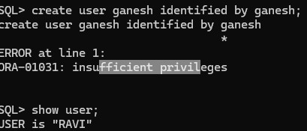

**How to interact with Oracle database software using web application?**

1) start the Oracle database software by using the web app icon on the desktop.

2) Login with DBA account credentials by following the below steps:

i) click on "Application Express"

ii) provide the details:

user name: system

password: system

click on "login.

3) to create the user follow the below procedure:

i) enter the database user name:ravi

ii) enter the application express user name: ravi

iii) enter the password: ravi

iv) enter the confirm password: ravi

v) click on "create workspace"

4) after that, we can login with that user by filling the user name and password.