**Install Required Extensions for VS Code**

[**Visual Studio Code**](https://code.visualstudio.com/)**is a source code editor for building modern web applications. It is a free and open-source editor. It supports a number of extensions that can be used for web application development.**

**Live Server**

**This extension is used for launching a development local server with a live reload feature for static and dynamic pages. This saves time for previewing the changes made to your source code by just making the changes in the VS code and saving the file. This will automatically refresh the browser and reflect the changes you have made in it instead of us manually refreshing the browser page.**

**\*Beautify**

**This extension is used for formatting files like HTML. The unformatted code in these files is converted into formatted, readable code by this extension. You can set this setting in the VS Code preferences, which will then automatically format all the code you have typed in the editor.**

**Better Comments**

**This extension is used for differentiating comment types like warnings, errors, highlights, and queries to improve the readability and understandability of the code.**

**Path IntelliSense**

**This extension is used for showing tips for the file paths of a project. This will come in handy while working on a project that has a large number of files in it.**

**Browser Preview**

**This extension is used for opening a real browser inside the VS Code editor to debug and check the changes you have made to the code instead of checking them on the browser each time.**

**Web Dev**

**This extension is a combination multiple extensions required for web development. This extension includes some of the major extensions like,**[**Live Server**](https://www.syncfusion.com/blogs/post/best-vs-code-extensions-web#live-server)**, [ESLint](https://www.syncfusion.com/blogs/post/best-vs-code-extensions-web" \l "es-lint" \o "Reference form #es-lint" \t "_blank), and**[**JavaScript (ES6) Code Snippets**](https://www.syncfusion.com/blogs/post/best-vs-code-extensions-web#javascript-code-snippet)**. Instead of installing these extensions individually we can install Web Dev extension.**

**Live Share**

**This extension enables real-time collaboration among developers. You can share your code with colleagues, allowing them to view, edit, and debug your code directly within their own Visual Studio Code environment. It’s a valuable tool for teams looking to enhance productivity and streamline the development process by enabling seamless code collaboration.**

**Docker**

**This is an essential tool for developers working with containerized apps. It streamlines the Docker container management process directly within the VS Code environment. This extension provides features like creating, managing, and debugging Docker containers and images. It also offers support for Docker Compose, making it simple to define and run multi-container apps.**

**HTML CSS Support**

**This extension provides autocompletion and suggestions for HTML and CSS code directly within the editor, which can significantly speed up coding and reduce errors. It offers features like class and ID attribute autocompletion, quick navigation to CSS definitions, and inline style support**

**\*Bracket Pair Colorizer**

**This extension simplifies code readability by adding colorization to brackets in your code. It assigns distinct colors to matching pairs of brackets, parentheses, braces, and other code-delimiting characters, making it easy to identify which opening bracket corresponds to a closing one. This visual aid is particularly valuable in large and complex code files, as it reduces the risk of bracket-related errors and enhances code navigation.**

**Code Spell Checker**

**This extension checks your code for spelling errors, ensuring that variable names, comments, and documentation are correctly spelled. It’s especially useful in larger codebases to enhance code readability and maintain professionalism in your projects. By highlighting and suggesting corrections for spelling mistakes, it assists developers in creating well-documented and easily understandable code, promoting better code quality and collaboration.**

**GitLens**

**This extension is used for getting information from a Git source that can be edited in the VS environment. Commit logs, file history, and more from the Git repository files can be viewed inside the VS code itself, and that saves time, too.**

**JavaScript (ES6) Code Snippets**

**This extension is used for setting shortcut triggers for JavaScript code that can be used to invoke a full code instead of typing out code on each instance. This will be useful while working on projects with a large amount of codes.**

**Polacode**

**This extension is used for taking code snippet screenshots. It can be used to copy and paste the code you need in snippet screenshots easily and save them after installing the extension.**

**Quokka**

**This extension is used for testing JavaScript code in the Visual Studio Code editor itself instead of checking it out in the browser console.**

**Prettier**

[**Prettier**](https://prettier.io/)**is a useful tool that automatically formats your code using opinionated and customizable rules. It ensures that all your code has a consistent format and can help enforce a specific styling convention in a collaborative project involving multiple developers.** **The Prettier extension for Visual Studio Code brings about a seamless integration between the code editor and Prettier, allowing you to easily format code using a keyboard shortcut, or immediately after saving the file.**

**JavaScript Booster**

**This extension upgrades Visual Studio Code with code actions to perform common refactoring tasks that occur when programming with JavaScript.**

**CSS Peek**

**The CSS Peek Extension lets you quickly view the CSS style definitions for various class names and IDs assigned in HTML.**

**There are three ways to use CSS Peek:**

* **You can hold down the Ctrl key and hover over a class name or ID to peek at its definition.**
* **You can use a keyboard shortcut to open a persistent definition window that displays the CSS definition of a class name or ID.**
* **You can use a keyboard shortcut to navigate to where the definition is located in its CSS file.**

**Intellisense for CSS Class Names in HTML**

**This extension can work hand in hand with CSS Peek, it provides code completion for the HTML class attribute from existing CSS definitions found in the current Visual Studio Code workspace.** **You’ll appreciate the benefits of this extension when using third-party CSS libraries containing hundreds of classes.**

**Visual Studio Intellicode**

**Artificial Intelligence continues to increase worker productivity in various jobs, and developers are not left out. IntelliCode is a tool that produces smart code completion recommendations that make sense in the current code context. It does this using an AI model that has been trained on thousands of popular open-source projects on GitHub.**

**When you type the . character to access an object method or fields, IntelliCode will suggest a list of members that are likely to be used in the present scenario.**

**IntelliCode is available for JavaScript, TypeScript, Python, and a number of other languages.**

**VSCode Icons**

**Icon packs are available to customize the look of files of different types in Visual Studio Code. They enhance the look of the application and make it easier to identify and distinguish files of various sorts.**

**VSCode Icons is one the most popular icon pack extensions, boasting a highly comprehensive set of icons and over 11 million downloads.**

**It goes beyond file extension differentiation, to provide distinct icons for files and folders with specific names, including package.json, node\_modules and .prettierrc.**

**Tailwind CSS IntelliSense**

[**Commands**](https://marketplace.visualstudio.com/items?itemName=usernamehw.commands)

**Console Ninja**

**Error Lens**

**Eslint**

[**File Utils**](https://marketplace.visualstudio.com/items?itemName=sleistner.vscode-fileutils)

**Git Graph**

**google-search**

**Highlight Counter**

**MetaGo**

**Nested Comments**

**PostCSS Language Support**

**Stylelint**

**Template String Converter**

**Toggler**

**How to install extensions?**

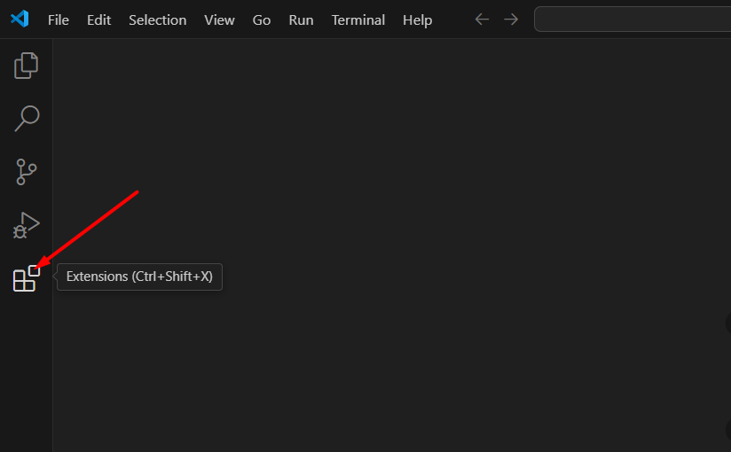

**Install LiveServer**

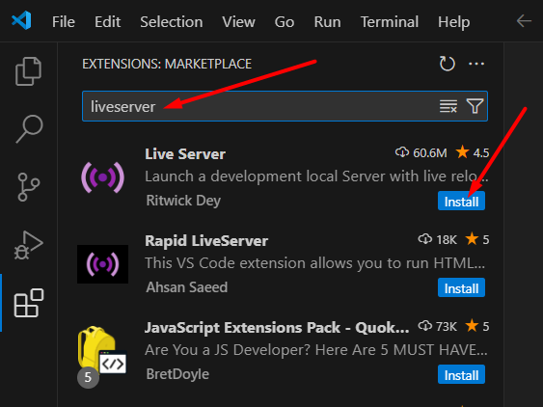

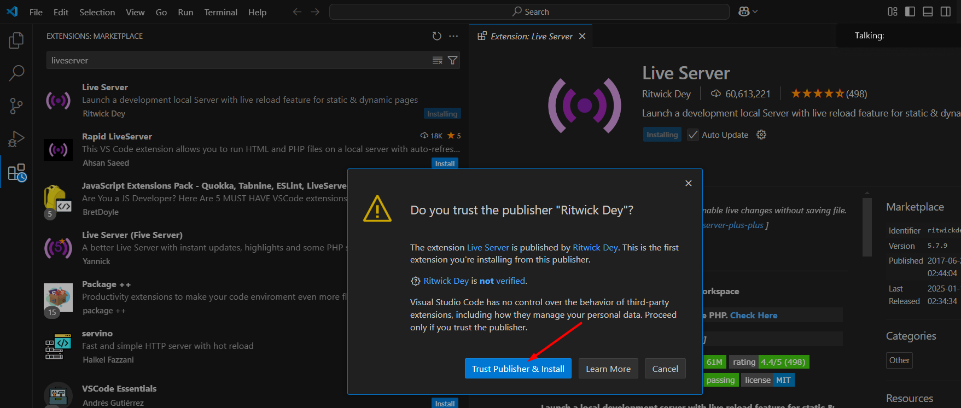

**Install Prettier**

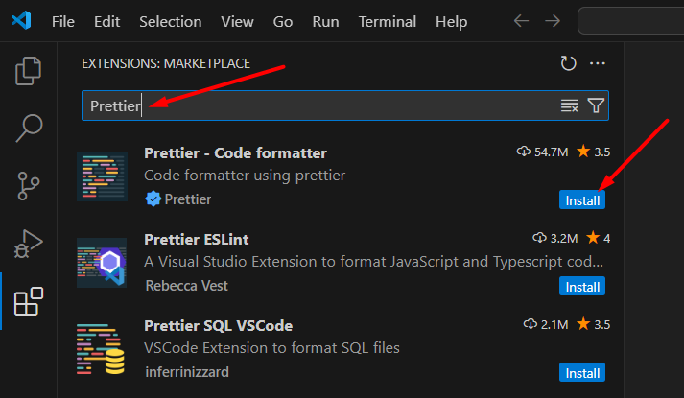

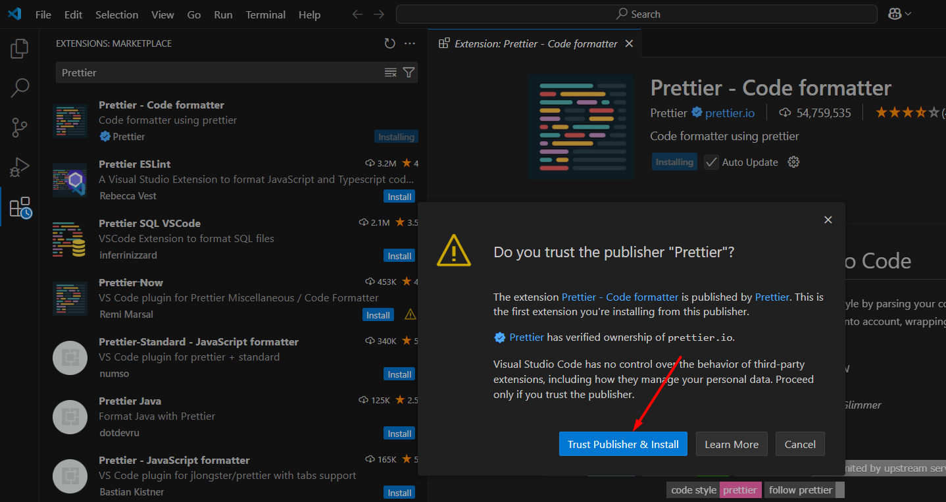

**Install IntelliCode**

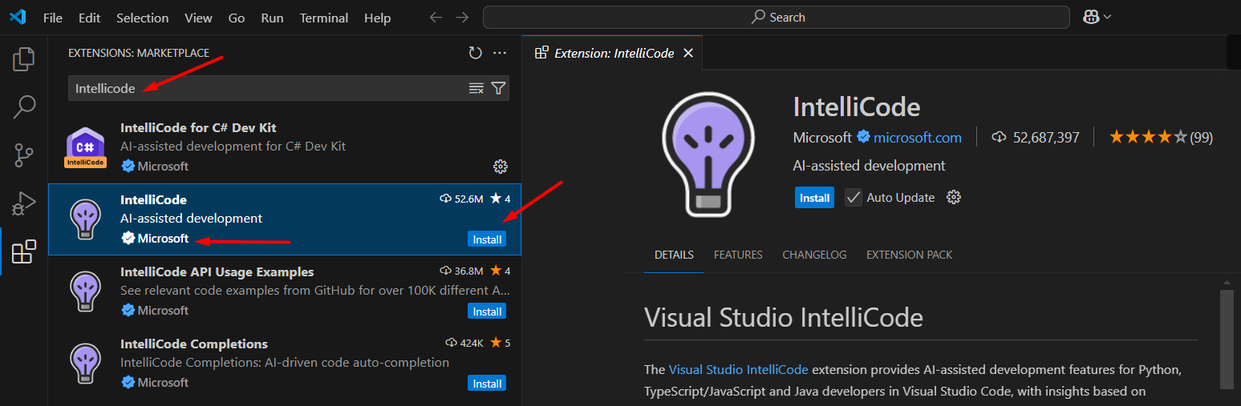

**Install VSCode Icons**

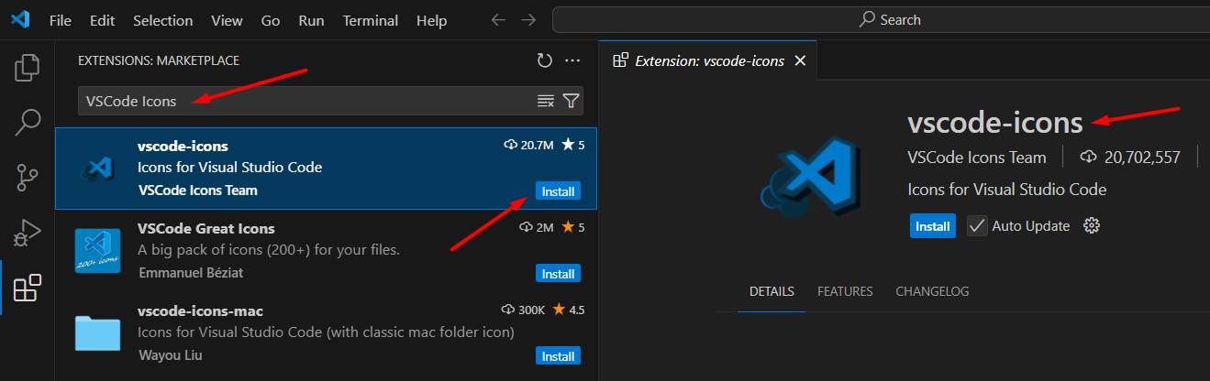

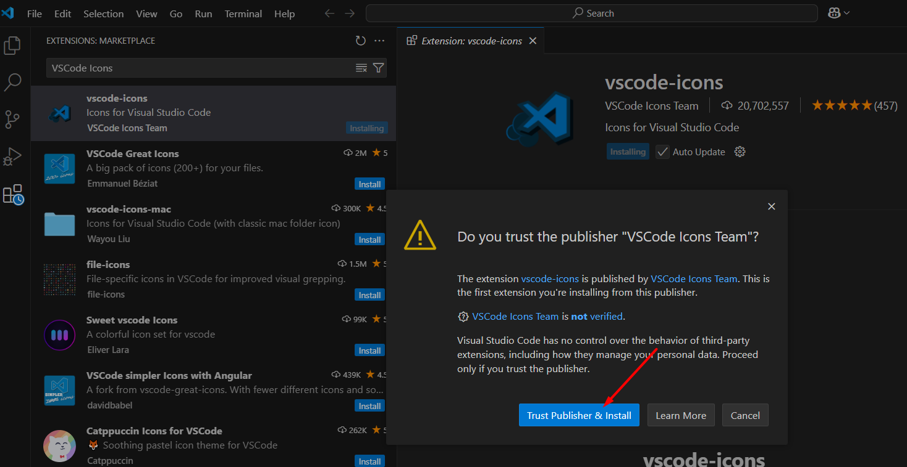

**Install Html Css Support**

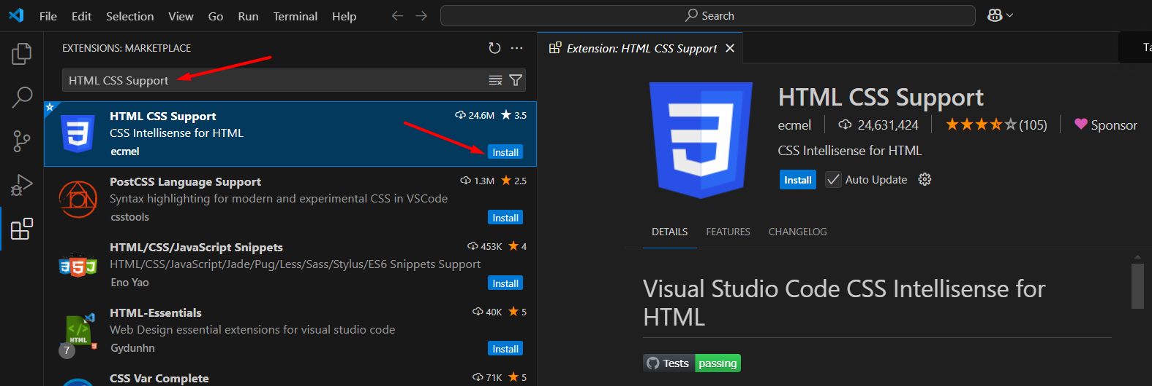

**Only for Demo**

