**BoxModel**

Box model:

* In simple words, box model is a technique used while placing the html elements in the visual area i.e. in body tag.
* Almost all visual html elements are treated as boxes.
* Using box model means, arrangement of small boxes in an order inside the big box called body tag.
* Each element (assume as box) comes with four properties, which gives impact visually.

They are:

1. **Content** – actual content area of the html element, like text and images appear
2. **Padding** - area attached around the content. The padding is transparent
3. **Border** - area that goes around the padding
4. **Margin** - area outside the border. The margin is transparent

* Most important point: html element width, height comes only after summing of above from both sides (left side + right side, top + bottom).
* Due to box model only, responsive web design implementation is easy.
* The properties padding, border, margin value is applicable on four sides of the content.
* If you want any side with different values, requires separate statement.
* Example margin:5px; applies on four sides , whereas margin-left:10px; is only applies on left side of the html element.

Example:

1. Let us take three html tags h1, h2, h3.
2. Place above three tags in body tag of html page with some text.
3. Change the background color of each tag separately using style tag.
4. Change the background color of body tag also.
5. Now observe the output.
6. Tags comes in the order h1 top, h2 middle, h3 bottom. i.e. h1 comes first, h2 second, h3 third.
7. H1, h2, h3 tags width is equal to width of body tag.
8. Now our requirement is, place three tags on same line.
9. Assume width of body tag is 100%.
10. Share this 100% equally among the three tags.
11. Width can be specified in % and pixels based on requirement.

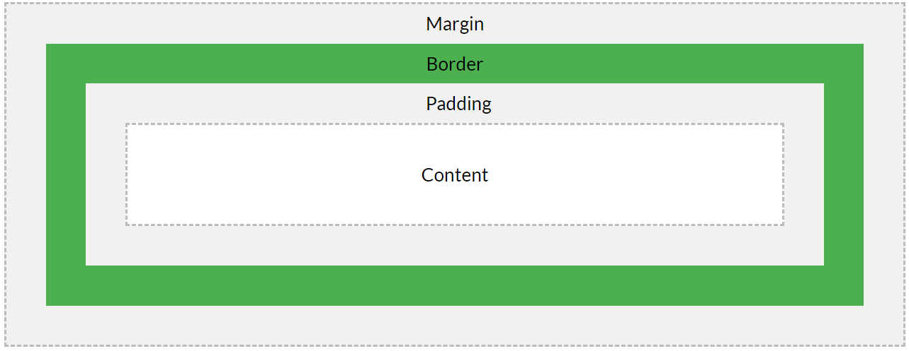

**Width**

2

3

4

1

6

5

7



1. Content width
2. Left Padding
3. Left Border
4. Left Margin
5. Right padding
6. Right border
7. Right margin

Total width of the html element is total of above 7 values.

**H1…H6 - HTML– Part 6**

* Six levels of headings defined by HTML using h1, h2, h3, h4, h5, h6.
* Heading gives identity , accessibility to webpage content.
* Each comes with predefined font, size, color and margins.
* H1 is the biggest and h6 is the smallest.
* For entire webpage content h1 should be the heading.
* Don’t use any elements inside heading tags.
* Once h1 is used, it is not allowed to use again in the same page as per SEO.
* For sub headings, paragraph headings depending the requirement we can use h2 to h6 any no of times.
* As per SEO h1, h2 and h3 are preferable for page indexing.
* Heading text must include important keywords related to content of the page.
* Generally use same keywords in h1 which are used in html page name, title tag.

Important Properties:

1. background-color
2. color
3. text-align
4. font-size
5. background
6. margin (four values)
7. border ( three values)
8. border-radius (can give four values)
9. width

10.padding

Note: Most browsers will display the <h1> <h2> <h3> <h4> <h5> <h6> element with the default values.

Note: css units – separate video. (px, em, %)

Note: default font size (usually 16px)

Note: How to prove these are default values?

h1 {  
  display: block;  
  font-size: 2em;  
  margin-top: 0.67em;  
  margin-bottom: 0.67em;  
  margin-left: 0;  
  margin-right: 0;  
  font-weight: bold;  
}