1. What is web?
2. Web Client – Client-Side Technologies
3. Web Server – Server-Side Technologies
4. http
5. request
6. response

**Internet:** In simple words it is a network of networks or a network with indefinite size. When we see internet in-terms of software, it is composed with two types of components. They are nothing but client and servers. Briefly they are as follows

Web Client 🡨---------------🡪 Web Server

E-Mail Client 🡨---------------🡪 E-Mail Server

FTP Client 🡨---------------🡪 FTP Server

DB Client 🡨---------------🡪 DB Server

API Client 🡨---------------🡪 REST Web Api Server

Chat Client 🡨---------------🡪 Chat Server

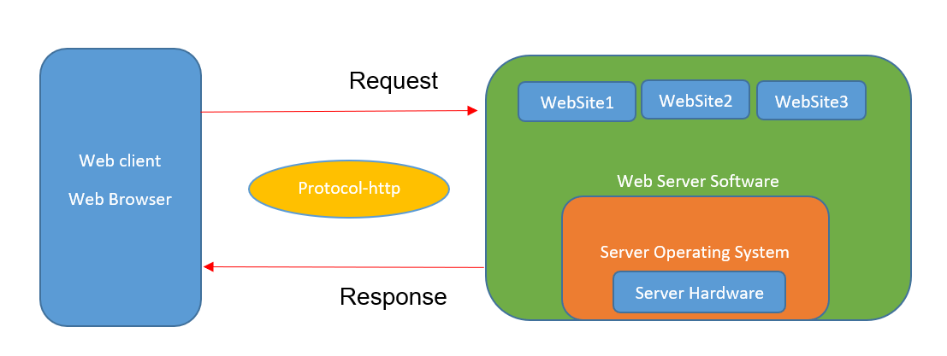

**Web:** Is nothing but a space which is under the control of web server which accessible to everyone via internet.

Initially for better understanding we can say that space as a folder. Web contains one or more web applications. **Web site is an example for web application**. All the web applications are not websites, but all the websites are web applications.

**Purpose of Web:** As web is accessible to everyone using internet, if any information placed in web that information was made accessible to everyone through internet. So primary aim of web is information sharing easily, without delay.

What is the format of information to store on Web?

1. File System.
2. Word, pdf, flat files (text files) excel and other formats.
3. Any of the above file type is used to store the information it leads to so many sharing problems.
4. Clients unable to see the file content. So really whether that file provides required content or not is unknown.
5. To open the file, need to be downloaded from server to client completely.
6. For a part of the content, total file need to be downloaded from server.
7. Even after downloading, that downloaded file is allowed to open by using its relevant software only. (Word – MS-Word, pdf – Pdf reader,)
8. Sometimes filename many not represent the exact content in files.
9. Random access of pages in not possible.

Note: This is implemented using FTP Server and FTP Client. No security to the file system of server.

To overcome the above problems we require,

1. A universal, common format to store the information.
2. Client can see the content without downloading it.
3. A common software is required to access any type of information at client side.
4. Random connectivity required among (pages) the information.
5. That format must be light weight.
6. Server file system not allowed to access by clients.

To fulfil above requirements a new Technology is required i.e., HTML.

**Web Server:** Is a Program which holds web applications in its space. Web Server functionalities are as follows

1. Receives request from web client.
2. Understands it
3. Processes it
4. Prepares Response
5. Sends Response to web client from which web server received the request.

Simple Example:

Student ----------------------🡪 Master relationship.

Student sends question to Master.

Master listens the question, understands it, prepares the answer

Finally, Master Sends Answer to Student for received the Question as response.

Note:

1. Students will be one or more

2. Only one Master

3. Each student can ask one or more questions.

4. For the all the students and their questions only one Master.

5. For proper communication while asking questions and giving answers both Student and Master should follow proper order, otherwise it may go meaning less.

Master is Webserver*

Student is Web client

**Website:** Is a collection of one or more webpages and it is under the control (deployed or hosted) of webserver.

**Webpage:** In simple words, webpage is a program using which information (data) is presented (visually) at client, inside the web client software (web browser). In Addition to the above input and output also is also performed. HTML is the one, using which web pages are created.

**Web Client:** Is nothing but web browser (chrome, fire fox, edge etc.) using client interacts with websites, which are hosted on web server. Web browser sends a request to web server. Server receives the request. Once server receives the client request (along with data), it tries to process the request. After the completion of request processing result will be send to web browser. This is called response from the server to client.

Request: data send by the by the web browser to the web server.

Response: data send by the Web Server to Web Client.