Request, Response object is divided into two parts – header and body. Data inside the header and body is in the form of key and value. Here keys can be predefined or developer defined.

**http/s:** For better communication between the web browser and web server request and response data (message structure) should be according to hypertext transmission protocol.

Important points must remember:

1. The Request send by Web client must be understandable to Web Server.
2. The Response send by Web Server must be in understandable format of Web client i.e. Web Browser.

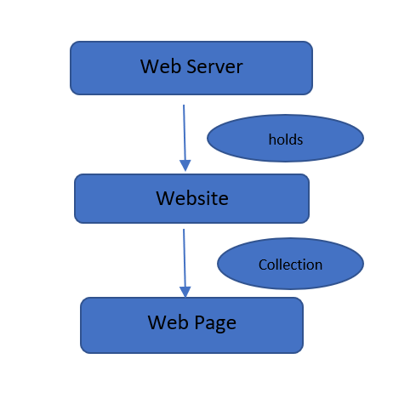

Webserver can hold one or more websites (web applications)

Website is a collection of one or more web pages.

A web page is create using HTML

HTML provides solution to all the problems raised due the use of files system.

Simple words HTML is used to format the information which we want share over the internet.

Now, try to understand about information:

1. Information which we want to share over the internet in the form of webpage.
2. Information about an organization, firm, product, any concept, company anything.
3. Example: School, A tourist place, A Research information on any concept, Review information on products etc.
4. General Information includes different types of elements like Text, Images, and Videos.
5. Again Text can be divided into Headings, Sub headings, paragraphs, important words etc.
6. For better readability, arrangement of information with proper look (size, color, alignment,…) is required.
7. Finally using HTML information is divided and formatted in the form of pages i.e. Webpages.
8. At the basic level HTML provides things to format the information, links among the information, identifying the different elements of the information (Headings, Sub headings, paragraphs, important words etc.).
9. At client side, Web Browser software is provided to view the webpages from web server. Universal common software to view any type of data from website.

Note: Based on the client requirements so many other technologies are required, they are divided into CST: Client-Side Technologies, SST: Server-Side Technologies.

Here I am trying to map requirement and the technology (basic) together.

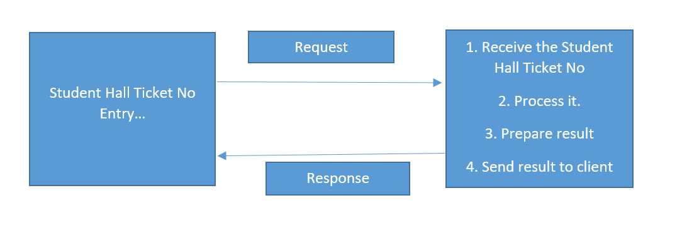

From the above Example:

Note:

Request includes implicit data and explicit data.

Response includes implicit data and explicit data.

Requirements are:

Client Side:

1. Webpage or pages to take student hall ticket number (other data) as input.
2. Hall ticket number validation at client side (related to size, format*)
3. Submit or Send request to Server along with input data (hall ticket number)

At Server Side:

1. Receiving the request along with data (hall ticket number)
2. Validate the hall ticket number, by connecting with data base where hall ticket numbers are stored.
3. If hall ticket number is valid, get the marks send the result to client in required format.
4. If hall ticket number is invalid send Error message to client in the required format.
5. Special case, if unable to process the request send Error Message to client in required format.

|  |  |  |
| --- | --- | --- |
| S.No | Requirement | Name of Technology |
| 1 | Present the information visually | HTML |
| 2 | For input and output at client side in webpage | HTML input controls |
| 3 | Manage the Visual Information or Style information among the website | CSS |
| 4 | Client Side Validation before sending request to server ,*(request and response processing in background) | *JavaScript and it’s frameworks – ajax,jQuery.  Html5 -few features |
| 5 | Responsive Web Design using predefined elements for everything | Bootstrap |

Once request is sent to server along the input data, at server side a program is required to

* Receive the request along with data
* Analyze, understand the request
* Process it (different types of logics, basic operations, validations, database, mailing, messaging etc.)
* Prepare the response
* Send the response to client browser

To perform above operations, separate technology is required because HTML unable to perform any of the above. Why, HTML is just a mark-up language not regular programming language.

In html **no data types, variables, operators, control structures, arrays, functions, data base api, and most important, Request and Response handling functions** at Server side.

Now, a new technology came i.e. SSC, SST. Server Side Coding, Server Side Technology or Server Side Programming.

Important SSP are:

1. Servlets, JSP with Java (for processing)
2. ASP with VB Script (for processing)
3. PHP (php provides processing logic)
4. ASP.NET with C# or VB.Net
5. Express with Javascript