**Day-01**

**20-03-2025**

**=================**

**While loop:**

**========**

**Q: When we required the for loop and when we required the while loop?**

for loop:

---------

When we can estimate the number of iterations, then we can use "for loop".

Ex:

47 is prime number or not

divide the 47 from 2 to 46

44-times, we need to divide

after the division of 44 times we can get the clarity that whether the number is prime or not.

While loop:

------------

When we cannot estimate the number of iterations, then we can use "while loop".

Ex: 1234 ==> 4-digit

987654321

12345678901234567890

Syntax of the while loop:

----------------------------

-> while loop can define with "while" keyword.

-> when we need to define the while loop, there are three things are required:

1) Initialization --> where or at which point the while loop can start

2) Condition --> until which value/point the while loop need to continue.

3) Update --> the difference from current value to the next value

10 to 100 with difference of 10

initialization = 10

condition <= 100

update = 10

Syntax:

--------

initialization

while condition:

loop statements;

update;

for:

initialization, condition and update all were integrated

using range()

Ex: range(10,101,10)

start = 10 (Initialization)

end with 100 (condition)

step = 10 (update)

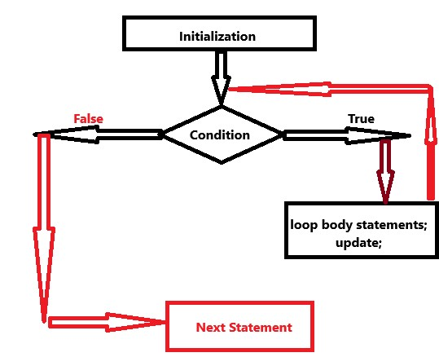

**# Write a python program to print all natural numbers from 100 to 1 with the difference of 10**

# expected output: 100 90 80 70 60 50 40 30 20 10

start = 100 # initialization

while start >= 1: # condition

print(start,end = "\t")

start = start - 10 # update

print()

print("Loop is completed!")

**Day-02**

**21-03-2025**

**==================**

**Q: Write a python program to take a number as an input and**

**find the number of digits in a given number.**

Solution:

--------

assume,

number = 1234

-> from the number

by removing digit by digit from right (least coefficient) to left (highest coefficient)

we need to count the digits of the number.

Logic:

------

number = int(input("Enter the number:")) # 1234

count = 0

n = number # 1234

while n != 0:

n = n // 10 # 123 12 1 0

count = count + 1 # count += 1 1 2 3 4

print("The total number of digits in a number",number,"is = ",count)

**Q: Write a program using python to accept a number as an input and find the sum of individual digits of the given number.**

Solution:

--------

Assume:

number = 1993

Expected: 1 + 9 + 9 + 3 ==> 22

How:

i) to get the individual digits from the number, we need to use '%' with 10

store that result in one variable like:

individual digits = number % 10

sum += individual digits

ii) after add of that digit, we need to remove that digit permanently by using '//' with 10

Logic:

-------

number = int(input("Enter a value:")) # 1993

sumOfDigits = 0

n = number # 1993

while n != 0:

digits = n % 10

sumOfDigits += digits

n = n // 10

print("The sum of all digits in a number",number,"is = ",sumOfDigits)

**Q: Write a python program to reverse the number.**

Solution:

---------

number = 1234

result = 4321

formula:

--------

reverse = 0

reverse = reverse * 10 + individual-digits

Logic:

------

number = int(input("Enter a value:")) # 1234

reverse = 0

n = number # 1234

while n != 0:

digits = n % 10

reverse = reverse * 10 + digits

n = n // 10

print("The number after the reverse = ",reverse)

Assignment:

-----------

1) Write a python program to accept a number as an input

and find the sum of even digits of the number.

Ex: 123456

-> 2 + 4 + 6 ==> 12

2) Write a python program to accept a number as an input

and print the product of individual digits of a number.

Ex: 1234

1 * 2 * 3 * 4 ==> 24

3) Write a python program to check whether the given number is palindrome number or not.

Hint:

-----

The reverse of number == given number ==> palindrome number

reverse of number != given number ==> not palindrome number