**Day-01**

**06-03-2025**

**=================**

**Control Statements:**

**=============**

Why control statements:

----------------------------

Sequential Execution:

------------------------

line by line execution or

linear execution

Ex:

banking:

withdraw:

minimum_balance = 1000

account_balance = 2000

withdraw = 1500

really you want to withdraw or not

2500

insufficient funds

1000

transaction complete

1) When the user want to execute one block out of multiple blocks of code, we need the control statements.

2) When we want to execute the certain block of code repeatedly, we need control statements.

3) when the flow of control can transfer from one block of code to another block of code within the same program, then also we need control statements.

Types of control statements:

--------------------------------

-> three types:

1) Conditional Statements

2) Loop Statements

3) Transfer Statements

**1) Conditional Statements**

**-------------------------------**

-> When the user want to execute one block of code out of multiple blocks of code, we need the conditional statements.

-> Also called as "Selection statements".

-> There are four types of conditional statements:

1) simple if statement

2) if else statement

3) if elif else statement

4) nested if else statement

1) simple if statement

-----------------------

Syntax:

if condition:

statement-1

statement-2

next statement

**# WRITE A PROGRAM TO TAKE A NUMBER AS INPUT IN PYTHON.**

**# CHECK WHETHER THE GIVEN NUMBER IS POSITIVE OR NEGATIVE.**

**# IF IT IS NEGATIVE, CONVERT THAT NUMBER INTO POSITIVE.**

number = int(input("Enter the value:"))

if number < 0:

number = -number

print("The Number After the conversion is = ",number)

print("The number is not converted because it is positive.")

2) if else statement

-----------------------

Syntax:

if condition:

statement-1

statement-2

else:

statement-3

statement-4

next statement

**# WAP TO ACCEPT A NUMBER AS AN INPUT IN PYTHON.**

**# AND CHECK WHETHER THAT NUMBER IS POSITIVE OR NEGATIVE.**

**# IF IT IS POSITIVE, THEN CONVERT INTO NEGATIVE AND VICE VERSA.**

number = int(input("Enter a number:"))

if number > 0:

number = -number

else:

number = -number

print("The number after the conversion is = ",number)

**# WAP IN PYTHON TO ACCEPT four VALUES OF THE SIDES AS AN INPUT.**

**# AND CHECK WHETHER THE SQUARE IS POSSIBLE OR NOT WITH THE GIVEN SIDE VALUES.**

Solution-1:

------------

side1 = int(input("Enter a value for side:"))

side2 = int(input("Enter a value for side:"))

side3 = int(input("Enter a value for side:"))

side4 = int(input("Enter a value for side:"))

if side1 == side2 and side1 == side3 and side1 == side4:

print("The square is possible with the given side values.")

else:

print("The square is not possible with the given sides.")

Solution-2:

-------------

side1 = int(input("Enter a value for side:")) # 10 # 6

side2 = int(input("Enter a value for side:")) # 10 # 7

side3 = int(input("Enter a value for side:")) # 10 # 8

side4 = int(input("Enter a value for side:")) # 10 # 9

# if side1 == side2 and side1 == side3 and side1 == side4:

if side1 == side2 == side3 == side4:# False and False

print("The square is possible with the given side values.")

else:

print("The square is not possible with the given sides.")

**Assignment:**

**=========**

1) WAP TO ACCEPT TWO NUMBERS AS AN INPUT AND FIND WHICH IS THE BIGGEST USING IF ELSE.

2) WAP TO FIND THE SUM OF TWO NUMBERS IF FIRST NUMBER IS SMALLER THAN SECOND OTHERWISE FIND THE DOUBLE TO THE SUM USING IF ELSE.

**Day-02**

**07-03-2025**

**===============**

3) if elif else statement:

--------------------------

Syntax:

if condition1:

statement-1

statement-2

elif condition2:

statement-3

statement-4

elif condition3:

statement-5

statement-6

......

....

elif condition(n-1):

statement-n

statement-n+1

statement-n+2

else:

statements

Next Statement

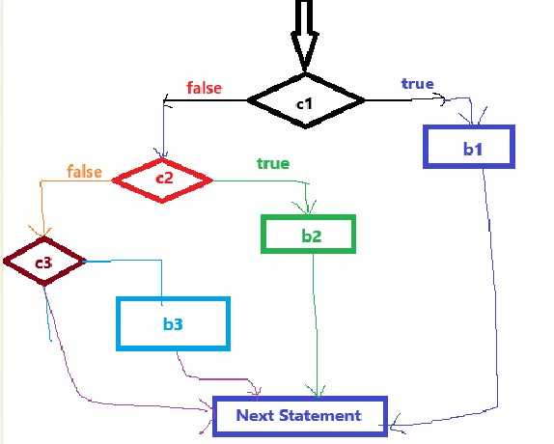

**# WRITE A PYTHON PROGRAM TO ACCEPT THREE INTEGERS AS INPUT**

**# AND FIND THE SMALLEST NUMBER AMONG THE THREE INTEGERS.**

num1 = int(input("Enter a value:")) # 11 33 33

num2 = int(input("Enter a value:")) # 22 11 44

num3 = int(input("Enter a value:")) # 33 22 22

if num1 < num2 and num1 < num3:

print(num1,"is smallest number among",num2,"and",num3)

elif num2 < num3:

print(num2,"is smallest number among",num1,"and",num3)

else:

print(num3,"is smallest number among",num1,"and",num2)

4) Nested if else:

------------------

Syntax:

if condition1:

if condition2:

inner_if1_block_statements

else:

inner_else1_block_statements

else:

if condition3:

inner_if2_block_statements

else:

inner_else2_block_statements

next Statement

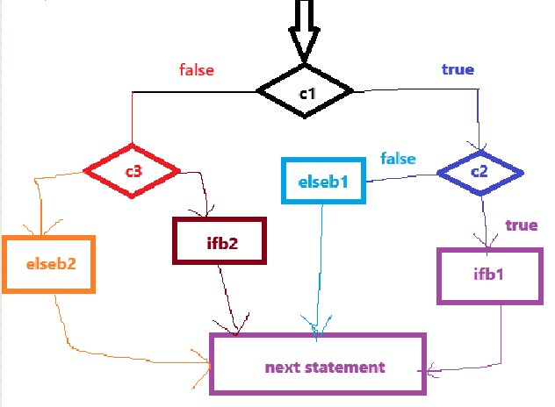

**# WRITE A PYTHON PROGRAM TO ACCEPT A YEAR AS AN INPUT**

**# AND CHECK WHETHER THE GIVEN YEAR IS LEAP YEAR OR NOT.**

**"""**

**leap year: the year should not be divided with '4' and also not with '100'**

**the year which are multiples of '100' are dividing with '400'**

**we can say those are leap years.**

**"""**

year = int(input("Enter a year:"))

if year % 4 == 0:

if year % 100 != 0:

print(year,"is leap year")

else:

if year % 400 == 0:

print(year,"is leap year")

else:

print(year,"is not leap year")

else:

print(year,"is not leap year")

**# WRITE A PYTHON PROGRAM TO MULTIPLY THREE INTEGERS BASED ON BELOW CONDITIONS:**

**# IF ANY OF THE NUMBER IS '7' THEN MULTIPLY THE NUMBERS WHICH ARE RIGHT TO '7'**

**# IF THE LAST NUMBER IS '7' THEN PRINT '-1' AS THE RESULT.**

**# NO NUMBER AS '7' THEN MULTIPLY ALL**

**"""**

**n1, n2, n3 = 7, 6, 8 ==> 6 * 8 ==> 48**

**3, 7, 9 ==> result == 9**

**1,2,7 ==> -1**

**5,6,8 ==> 5 * 6 * 8 = 240**

**"""**

n1 = int(input("Enter first number:"))

n2 = int(input("Enter second number:"))

n3 = int(input("Enter third number:"))

result = 1

if n1 == 7:

result = n2 * n3

elif n2 == 7:

result = n3

elif n3 == 7:

result = -1

else:

result = n1 * n2 * n3

print("The Multiplication of the three number's result = ",result)

Assignment:

========

1) WRITE A PYTHON PROGRAM TO FIND THE BIGGEST NUMBER AMONG FOUR INTEGERS.

2) WRITE A PROGRAM IN PYTHON TO ACCEPT AN INTEGER AS AN INPUT AND DO THE FOLLOWING:

i) IF THE GIVEN NUMBER IS DIVISIBLE WITH '3', THEN: PRINT "MULTIPLE OF 3"

ii) IF THE GIVEN NUMBER IS DIVISIBLE WITH '5', THEN: PRINT "MULTIPLE OF 5"

iii) IF THE GIVEN NUMBER IS DIVISIBLE WITH BOTH '3' AND '5', THEN: PRINT "MULTIPLE OF 3 AND 5 BOTH"

iv) OTHERWISE, PRINT: "NOT MULTIPLE OF 3 AND 5 ALSO".

**Day-03**

**11-03-2025**

**==================**

**# WRITE A PYTHON PROGRAM FOR LOGIN SYSTEM.**

'''

assume:

user-name : "admin"

password: "admin123"

username == user-name

password == password

login success

login fail

'''

userName = input("Enter the user name:")

password = input("Enter the password:")

if userName == "admin" and password == 'admin123':

print("Login Success")

else:

print("Login Fail")

**'''**

**Write a program using python based on following requirements:**

**i) if the distance from the restaurant to the user is below or equal to 4km, no delivery charges**

**applicable**

**ii) if the distance is above 5km and below or equal to 8km, delivery charges should be 5% on purchase**

**iii) if the distance is above 8km, delivery charges should be 8% on purchase.**

**find the total bill of customer**

**'''**

'''

purchase = 250

distance = 3km

delivery charges ==> 0/-

totale fare ==> purchase + delivery charges ==> 250 + 0 ==> 250/-

distance = 5km

delivery charges ==> 0 to 4 (0/-) + 5 to 8 ==> 0 + 250 X 5/100 ==> 12.5/-

total fare ==> 250 + 12.5 ==> 262.5/-

distance = 10km

delivery charges ==> 0 to 4 (free) + 5 to 8 (5%) + 9 to any (8%)

0 + 12.5 + 20 ==> 32.5/-

total fare ==> 250 + 32.5 ==> 282.5/-

'''

purchase = float(input("Enter the cost of food:"))

distance = float(input("Enter the distance:"))

if distance <= 4.0:

deliver_charges = 0

totalFare = purchase + deliver_charges

elif distance > 4.0 and distance <= 8.0:

delivery_charges = purchase * 5/100

totalFare = purchase + delivery_charges

else:

delivery_charges = (purchase * 5/100) + (purchase * 8/100)

totalFare = purchase + delivery_charges

print("The total fare of the customer = ", totalFare)

Assignment:

--------------

1) Write a program using python to do by follow below:

if day is '1', print "Sunday"

day is '2' print "Monday"

...

day is '7' print "Saturday"

2) Write a python program to accept five subject marks as an input.

Calculate the total marks and percentage of the student based on marks.

And print student grade by following below:

i) percentage >= 85 ==> 'A+'

ii) percentage >= 75 and percentage < 85 ==> 'A'

iii) percentage >= 70 and percentage < 75 ==> 'B'

iv) percentage >= 60 and percentage < 70 ==> 'C'

v) percentage >= 50 and percentage < 60 ==> 'D'

vi) percentage >= 40 and percentage < 50 ==> 'E"

vii) percentage < 40 ==> "Fail"