

* **JENKINS MASTER-AGENT ARCHITECTURE:**

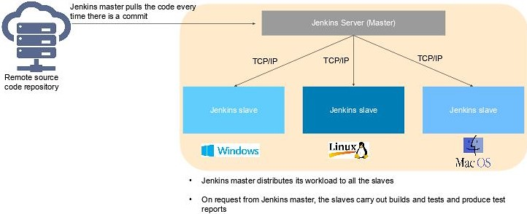

**JENKINS MASTER:**

* The Jenkins master simply represents the base installation of Jenkins.
* The master will continue to perform basic operations and serve the user interface, while the slaves do the heavy lifting.
* Master will be scheduling build jobs.
* Dispatching builds to the slaves for the actual execution.
* Monitor the slaves.
* Recording and presenting the build results.
* A Master instance of Jenkins can also execute build jobs directly.

**JENKINS SLAVE**

* A Slave is a Java executable that runs on a remote machine.
* Slaves can run on a variety of operating systems.
* It hears requests from the Jenkins Master instance.
* You can configure a project to always run on a particular Slave machine or simply let Jenkins pick the next available Slave.

**JENKINS AND AGENTS**

* Jenkins runs its jobs on agents, choosing them based on availability. You can add a Jenkins agent manually, and Jenkins doesn't know or care whether an agent is a physical or virtual machine.
* To set this up, you must configure a Instance before adding it as a Jenkins agent.

**STEP 1: Setting Up Hostname**

#hostname Jenkins-Agent

#vim /etc/hostname

Jenkins-Agent

#bash

**STEP 2: Installing Java**

#yum install java-11-openjdk

#java –version

**STEP 3: Create directory for saving Jobs**

#mkdir /opt/jenkins

**ADD AN INSTANCE AS A JENKINS AGENT:**

To add your VM as a node in Jenkins, go to the Manage Jenkins panel and select Manage Nodes.

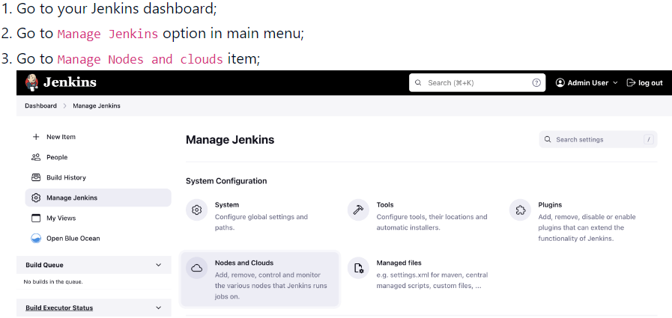

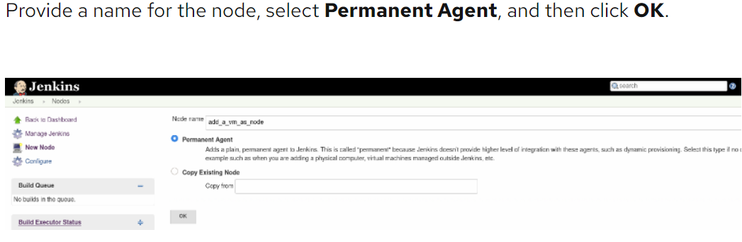

**Add Remote root directory:** /opt/Jenkins

**Label:** Jenkins-Slave

**Launch method:** Launch agent by connecting it to the controller

**Select Use WebSocket option**

**Finally:** Save

**NOTE:** By default, Node has been Offline

**Connecting Jenkins-Agent to Jenkins-Master:**

Go to Jenkins-agent Machine

Open Command Line Interface

Download and Run the Following commands

**STEP 1: Download agent.jar file**

#wget **agent,ar** file url adddres

**STEP 2: Run the command**

#java -jar **agent.jar** -jnlpUrl http://54.80.2.90:8080 /computer/…………. etc

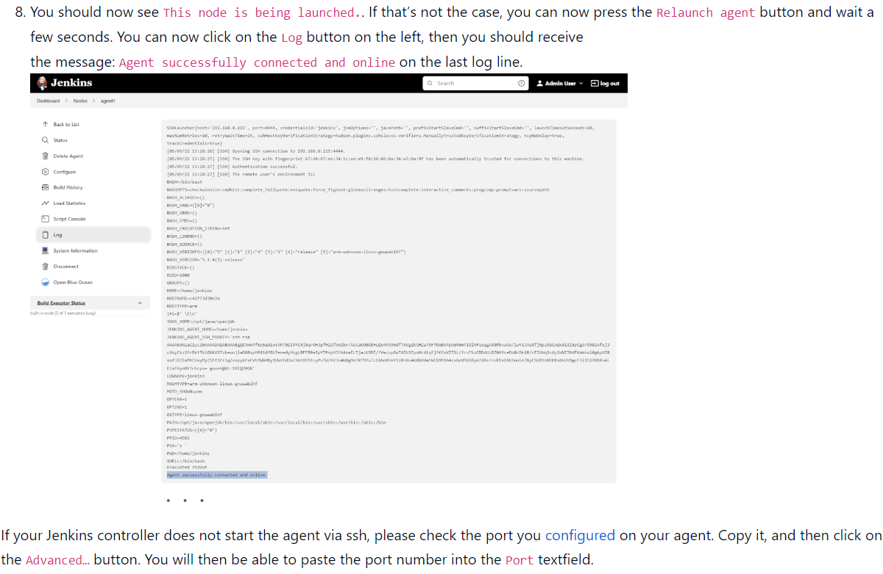

**Now Agent Will be Online**

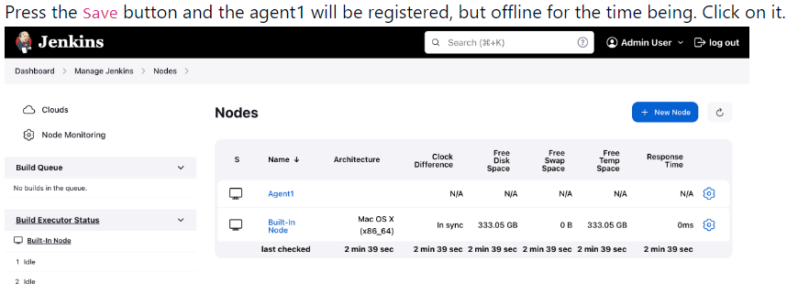

**Delegating the first job to Jenkins-Agent:**

**Start your build:** In your local instance of Jenkins, start a build. Jenkins executes all commands on your Instance.