**Day-01**

**20-02-2025**

**===============**

**Python Fullstack**

**===========**

Duration: 5 months

The whole course divided into three modules:

Module-1

======

core python

Database

Module-2:

=======

Advanced Python

UI

Module-3:

=======

Frameworks

Django, FastAPI

Mini project

UI Frameworks

React JS

Mini Project

Major Project

Devops and cloud tools

**Fullstack:**

**=======**

-> It is a process

of web application development.

**Web application:**

**===========**

-> Software is collection of programs for achieving the multi-tasking.

-> Same like the software, the application is also the collection of programs.

-> Application can always run on the platforms.

Ex: WhatsApp ==> android/ios (platforms for mobile)

Notepad ==> windows (platform)

-> The software not required any platform to run.

-> The applications can run/use over the internet called as "Web applications"

Ex: IRCTC, Youtube, Amazon etc.

**High-level architecture of Web application:**

**============================**

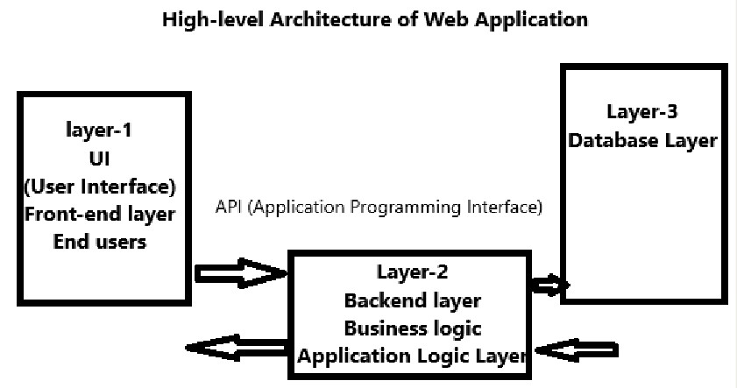

-> This consisting of:

1) Front-end layer is called as "UI (User Interface)"

Technologies:

HTML, CSS, JavaScript, Bootstrap, React

2) Backend layer is called as "Application logic layer" or "Business logic layer".

Technologies:

C/C++/Java/Python/PHP/C# etc.,

3) Layer-3 is called as "Database layer"

Technologies:

Database: Oracle/MySQL/SQL Server/Postgre SQL etc...

Database Programming Language: SQL