**Programming Language Fundamentals:**

==================================

Languages are used for the interactions.

-> Languages are classified into two types:

1) Natural Languages

2) Programming Languages

-> Natural Languages can be used to for the interaction between users/human

Ex: Telugu, Hindi, English, etc.

-> When a person want to interact with a computer/machine, we can use "programming languages".

-> Programming languages are classified into three types:

1) Binary Languages

2) Assembly Language

3) High level Language

**Binary Language:**

**===========**

-> from early 1960's the computer is available for us.

-> Super computer can understand only two digits:

1 and 0

-> When an instruction can be write in 1's and 0's called as "binary instruction".

Ex: A 65

According to the standard ASCII (American Standard Code Information Interchange), the characters can be numbered:

0 to 9 ==> 48 to 56

A to Z ==> 65 to 90

a to z ==> 97 to 122

-> if you want to send a letter 'A' to the computer:

A => 1000001 (binary code)

-> Writing of binary code (machine instruction) for each and every letter is really difficult for humans. That is the reason binary languages are not in demand in the market.

**Assembly Language:**

=============

sum of two numbers ==> add a b

sub, mul etc.

-> Assembly languages are with some predefined token and words.

With these we can able to develop anything easily.

-> When an application want to develop in one processor this may or may not extend to another processor.

That we need to develop any application uniquely from processor to processor.

**High Level Languages:**

===============

#include<stdio.h>

void main(){

printf("Hi");

}

-> Platform independent

-> processor independent

-> User friendly languages

Ex: C, C++, Java, Python etc.

Translators:

===========

Kind of software

Translate the code from one form to another form

High level =======> machine level

-> three types:

1) Assembler

2) Compiler

3) Interpreter

Q: DO WE ABLE TO DEVELOP ANY CODE USING ENGLISH/TELUGU/URDU/HINDI?

No, because these languages does not have translators.

How we can write programs using any language?

=============================================

Program:

========

Collection/set of instructions.

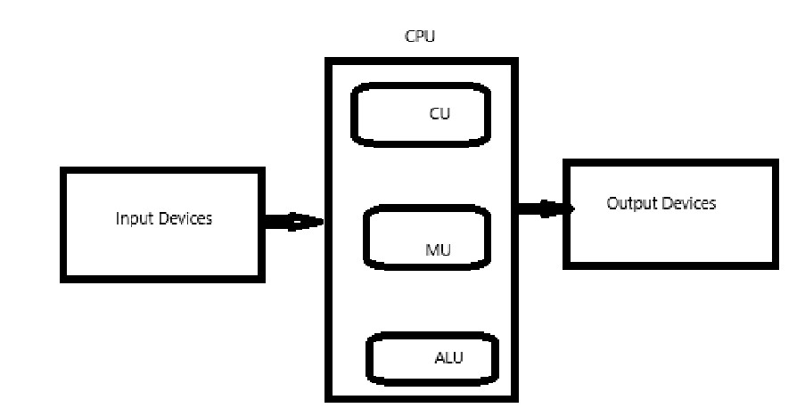

=> to write any program using any programming language:

we have to use five types of statements and 5-types of tokens:

1) Input Statement

2) Output Statement

3) Control Statement

4) Memory Statement

5) Arithmetic and Logic Statement

==> 5-types of Tokens are:

1) Keywords

2) Identifiers

3) Literals

4) Operators

5) Strings