**Do-while**

**09-03-2025**

**===============**

-> do is one of the keyword

-> while is also a keyword

-> do-while is one of the loop exit control statement.

-> The do-while can check the condition after visiting the loop body. If the condition is "true", then it continue to execute the loop body again otherwise, the loop body can be get stopped.

-> If the condition is "false" also the loop body can be get execute at least for one time. But the while loop is not like that, the number of iterations are '0' of the condition is "false" for initially only.

while Vs do-while:

---------------------

1) while is loop entry control statement

whereas the do-while is loop exit control statement.

2) while can check the condition before going to start the loop body

but do-while can check the condition after visiting the loop body.

3) while have '0' zero iterations when the condition at begin is "false"

whereas the do-while have at least one iteration even the condition at begin is "false".

Syntax for the do-while:

---------------------------

initialization

do

{

loop body

with statements;

update

}

while(condition);

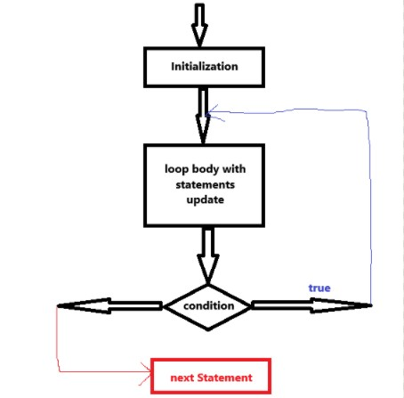

**/* WRITE A JAVA PROGRAM TO PRINT THE SUM OF ALL ODD NUMBERS BELOW TO 50 */**

class SumOfOddNumbers{

public static void main(String[] args)

{

int n = 50;

int sumOdds = 0;

do{

if(n % 2 != 0){

sumOdds = sumOdds + n; // 49 96

}

n--; //49 48 47

}while(n > 0);

System.out.println("The sum of all odd numbers up to 50 is = "+sumOdds);

}

}