**Day-03**

**Java Programming Fundamentals**

**===========================**

Java Programming Fundamentals:

=====================

Java Applications:

==================

-> James Gosling ==> founder of the java

-> Java developed at Sun micro System, 1995

-> officially available from 1996

-> Java applications are based on java platform.

-> Three are different java platforms:

1) Java SE (Standard Edition)/Core java

==========================

-> This can use to develop the desktop applications.

-> Desktop apps can download and install into local machines and monitored by one user at a time.

Ex: Notepad, MS Paint, Calculator etc.

2) Java EE (Enterprise Edition)

====================

-> To develop enterprise applications (Web applications), Java EE can be used.

-> Web applications can run over the internet.

-> Web applications can be used by more than one user.

Ex: Youtube, Gmail, Amazon, Ashok IT etc.

3) Java ME (Micro Edition)

==================

-> Java ME can be used to develop:

gaming applications

distributed applications etc.

-> When an application can interact with other applications for accomplish the functionality, such type of applications are called as "Distributed applications".

Ex: WhatsApp

database/server

internal storage

Phonepe

Phonepe ==========> bank server

**Java Features:**

**==========**

1) General Purpose programming language

2) High level programming language

3) Processor independent language

4) Platform independent language

5) Object oriented programming language

6) Java is secured language

7) Portable

High level programming languages are classified into three types:

1) Procedural languages

================

-> are also called as "functional programming languages".

because these are with full pre-defined functions.

Ex: C, C++, Python.

2) Object based languages

=================

-> The languages which can use only class and object from OOPs called as "Object based languages".

Ex: VB Script

3) Object Oriented languages

===================

-> The languages which can implement concepts and principles of OOPs, called as "Object oriented programming languages".

Ex: C++, Java, Python etc.

Object Oriented Programming System (OOPs)

concepts: class, object, method, constructor, destructor etc..

principles: Encapsulation, Inheritance, Abstraction, Polymorphism

**Java program:**

**==========**

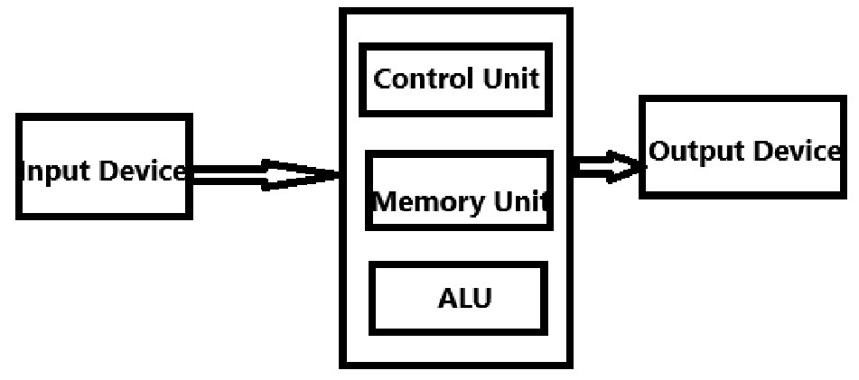

-> According to the computer architecture,

to write any java program,

we need 5-types of statements:

1) Input Statement

2) Output Statement

3) Memory Statement

4) Control Statement

5) Arithmetic and Logical Statement

Ex: int a = 10;

-> along with statements, we also need 5-types of tokens:

1) Keywords

2) Identifier

3) Operators

4) Literals

5) Strings